**PROJECT REPORT**

**Topic:** Jumbler

**About:** Jumbler is a webpage made for finding the jumble words and list of all words which can be forms by rearranging the alphabets (all or few) of the given word.

It is generally used by students for their academic or non academic works.

The main feature of this webpage is its speed .Out of 2,36,786 record it can search words within a second.

**Technologies used**: PhP, SQL, HTML, CSS, JavaScript, Jquery ,Xampp

**Editor used:** Sublime text

**Front-end:** HTML,CSS,JavaScript,Jquery,PhP

To make website interactive and doubt free and easy to use

**Back-end:** PhP, SQL

To make website interactive and more dynamic.

**Database:** Database consists of 2 table viz.:

1. Database :Contains the database of all meaningful English words with alphabet count in each word
2. History :contains list of words searched.

**Logic:**  Alphabet count of each words is calculated and is compared with every word in database.

**Screen-Shots:**

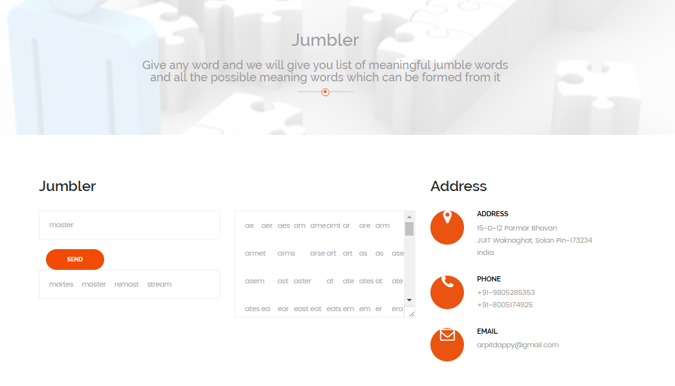

**Made by:** Arpit Rathi

CSE (133202)

Jaypee University of Information Technology